Square wire / 6mm stone
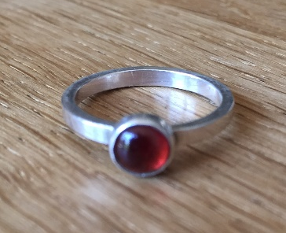

Round wire / 6mm stone
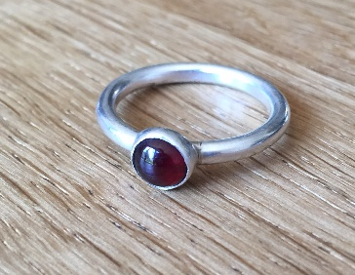

Sheet / 6mm stone
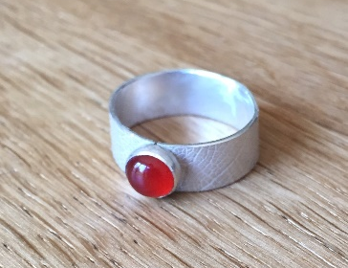

D wire and 5mm stone
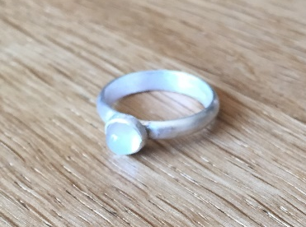

Cabochon stone

Bezel cup
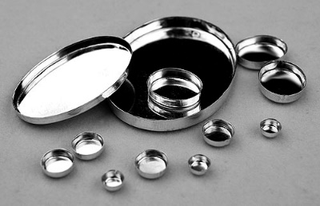

Square wire 2mm (7cm length):
http://www.rashbel.co.uk/precious-metal-brass-copper-silver-gold-bullion/silver-bullion/silver-925-wire/silver-925-square-wire/Silver-925-square-wire-2mm

Link to 6mm bezel cup: www.rashbel...............

Round wire 2.5mm x 7cm length:
http://www.rashbel.co.uk/precious-metal-brass-copper-silver-gold-bullion/silver-bullion/silver-925-wire/silver-925-round-wire/silver-925-round-wire-2.5mm-soft

Link to 6mm bezel cup: www.rashbel...............

Sheet 0.8mm (7mm x 7cm long)
http://www.rashbel.co.uk/precious-metal-brass-copper-silver-gold-bullion/silver-bullion/silver-sheet/silver-925-sheet/silver-925-sheet-0.8mm

Link to 6mm bezel cup: www.rashbel...............

D wire 7cm length
http://www.rashbel.co.uk/precious-metal-brass-copper-silver-gold-bullion/silver-bullion/silver-925-wire/silver-925-wire-D-shape/silver-wire-half%20round-D%20shape-925%20-8002878

Link to 5mm bezel cup: www.rashbel...............

Stone dealers: (Cabochon stone no less than 5mm round)
http://www.manchesterminerals.co.uk/acatalog/Real_Gemstone.html
http://www.wardgemstones.com/
http://www.rashbel.co.uk/gemstones-rough-cabochon-faceted

Bezel cups
http://www.rashbel.co.uk/jewellery-making-findings/bezel-cups-and-settings/silver-bezel-cups-settings-bezel-wire-settings-strip

